Visiting cards of our accommodations
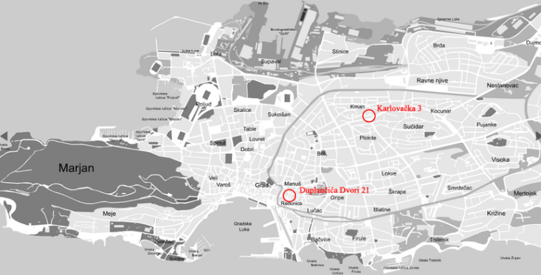
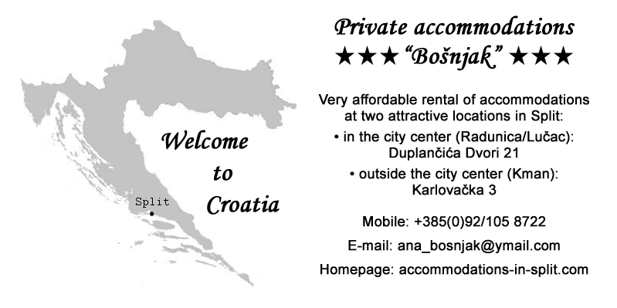
Private accommodations “Bošnjak”
Very affordable rental of accommodations in Split:
• in the city center (Radunica/Lučac): Duplančića Dvori 21
• outside the city center (Kman): Karlovačka 3
Mobile: +385(0)92/105 8722
E-mail: ana_bosnjak@ymail.com
Homepage: accommodations-in-split.com

